**Contents**

Opening

Designs

Wireframes

1. Index.html
2. Bio.html
3. CV.html
4. Contact.html

Prototypes

1. First thought
2. After CSS
3. Tab

Activity Sequence Diagrams

CSS Style Logic

Fonts

Navigation Diagram

Favicon extra

1. No favicon page
2. Page using favicon

Final product

1. Index
2. Bio
3. Curriculum Vitae
4. Contact form
5. Footer
6. Flexbox

References

**Opening**

Starting with the assignment, I looked to the joel.sh example page which was given to me.

I used some ideas on my Curriculum vitae page, about how it should have looked like. For the fonts used in my page I decided that, I wanted something serious but still playful and easy for the user to see. I went with Amaranth, Audiowide and Ultra as my fonts used in my title, footer on copyright and for my main text. This assignment took over 10 weeks and up to 10 commits on github to be completed, I found the style I will be using for the whole site around the 3rd week and stick with it till the end.

**Designs**

Wireframes

Index.html

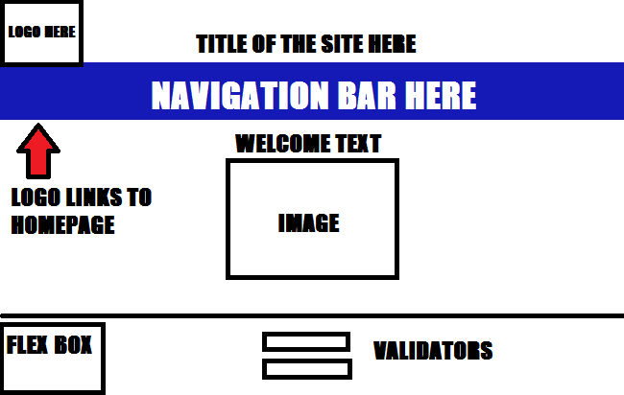

Bio.html

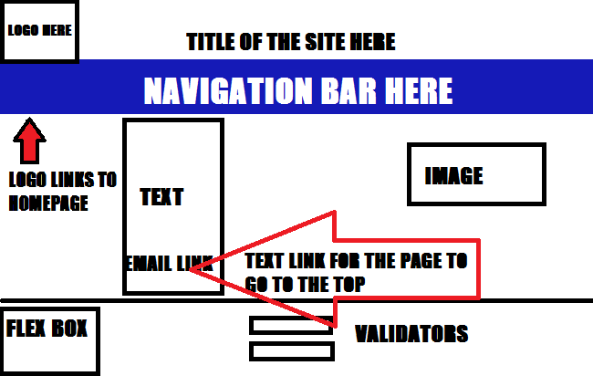

cv.html

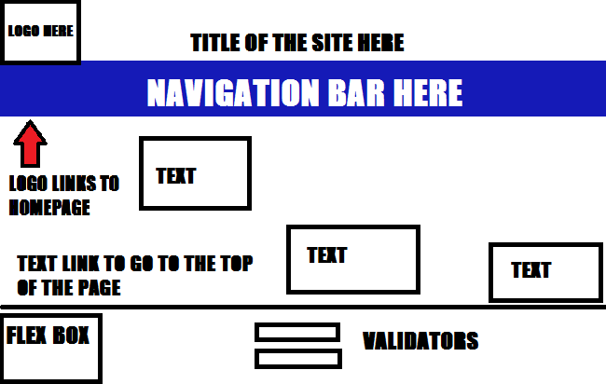

Contact.html

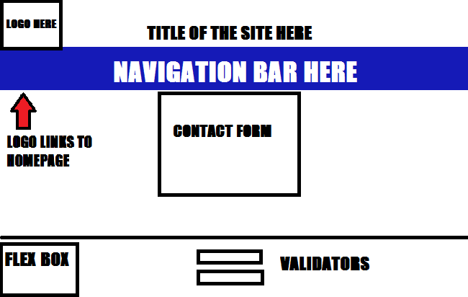

**Prototypes**

First thought

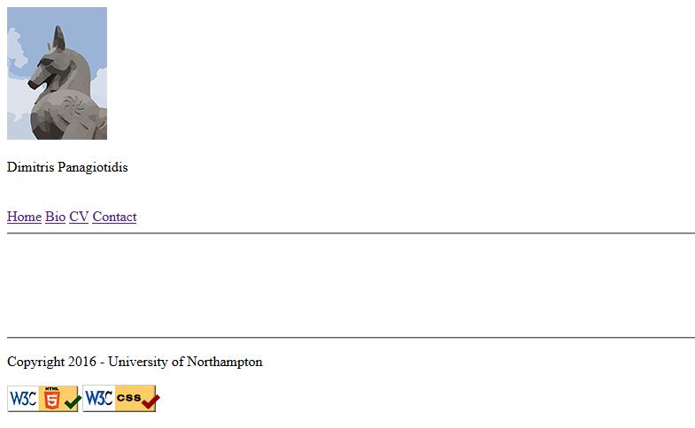

After CSS

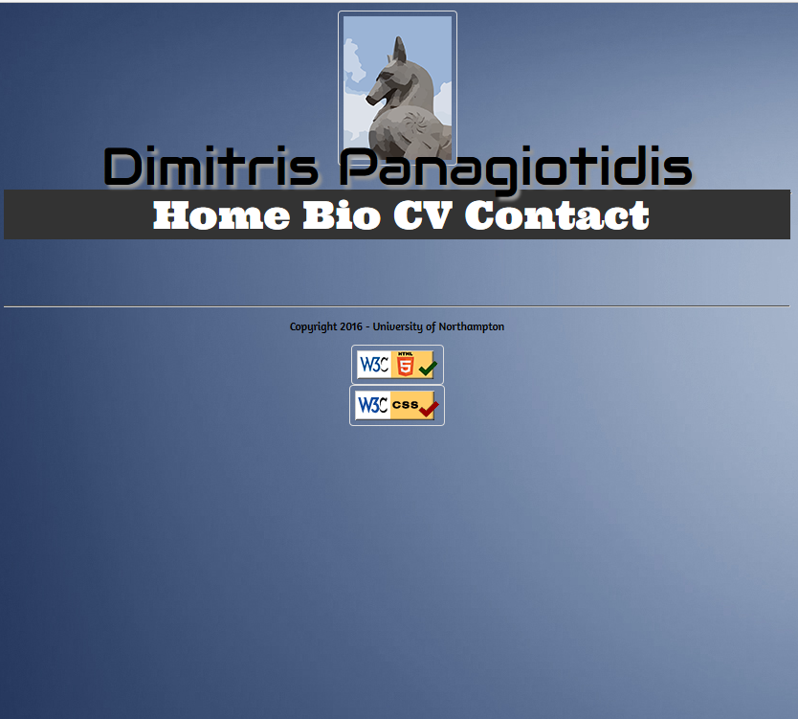

Tab



As we see here I wanted something simple and minimalistic at the same time, but still look like a page with lots of stuff to see. The page is still empty because this is the prototype product it is still the thought that was on my mind.

**Sequence Diagram**

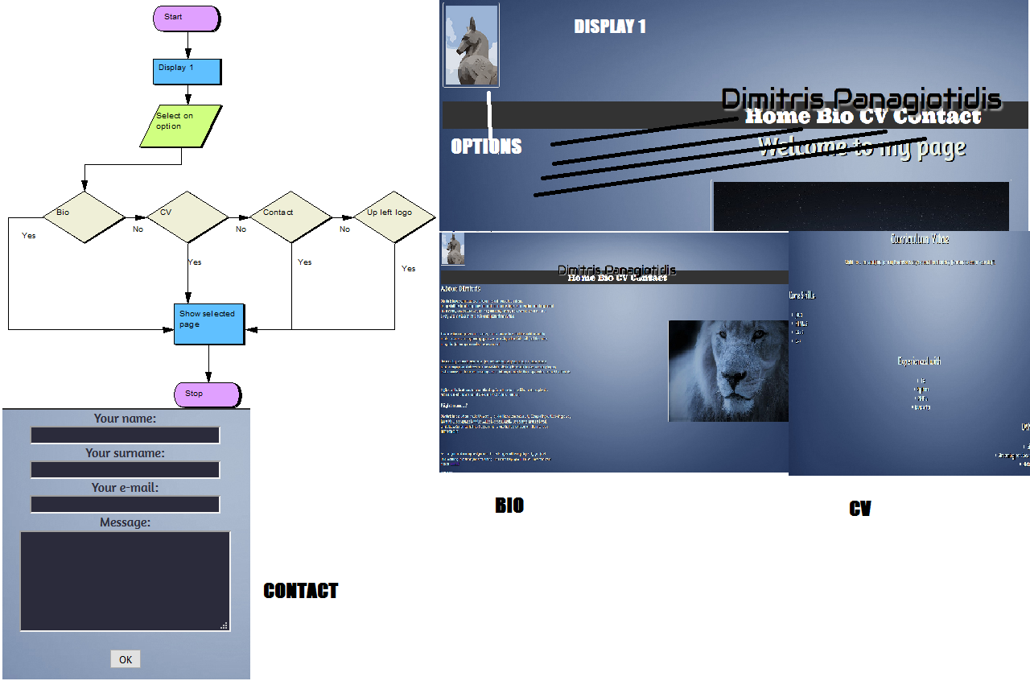

**CSS Style Logic**

Linking CSS to my Html, made my html page look better with the modifications I used different fonts on different places to show that my page is not simple. Using dark colors would make my page look hard to read, so I decided to use dark blue colors so it can still be dark, but have a lighter color in it blue is a fine color to be used in a web page because, it is an easy color for most of the users to see. Colorblind users such as myself, prefer the color blue rather than red or green, it does not make the eye tired. Using white font color on dark backgrounds makes it easier to read, I used black color letters at first and it was hard to read.

**Fonts**

The fonts used for this assignment are Amaranth, Audiowide and Ultra according to what I said above.

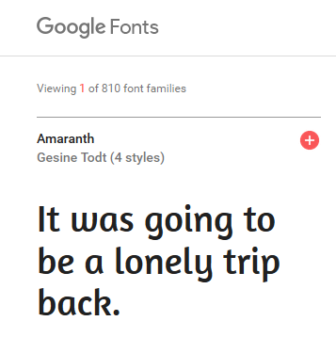

(Google Fonts, 2017)

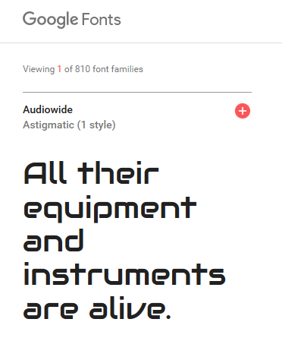

**Navigation Diagrams**

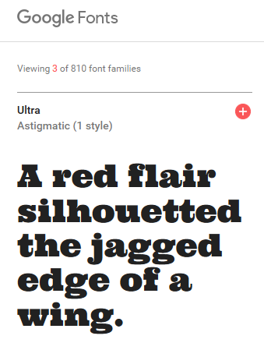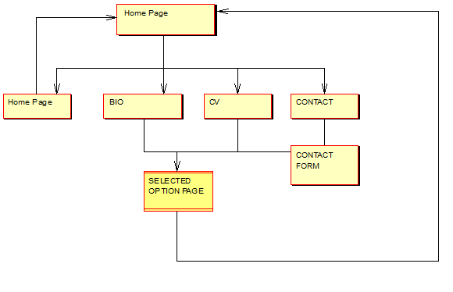

**Favicon Extra**

Favicon means favorite icon, actually in this case I made a favicon on a site. It is a really small icon used in the tab like the most sites in the internet, it is usually the logo of the site used on the tab so it does not look empty.

No favicon page

C:\Users\JACKAL\AppData\Local\Microsoft\Windows\INetCache\Content.Word\no favicon prototype.png

Page using favicon

C:\Users\JACKAL\AppData\Local\Microsoft\Windows\INetCache\Content.Word\web homepage favicon.png

**Final product**

Index.html

After 10 weeks I came to a conclusion, with my site look like I wanted it to be and completed.

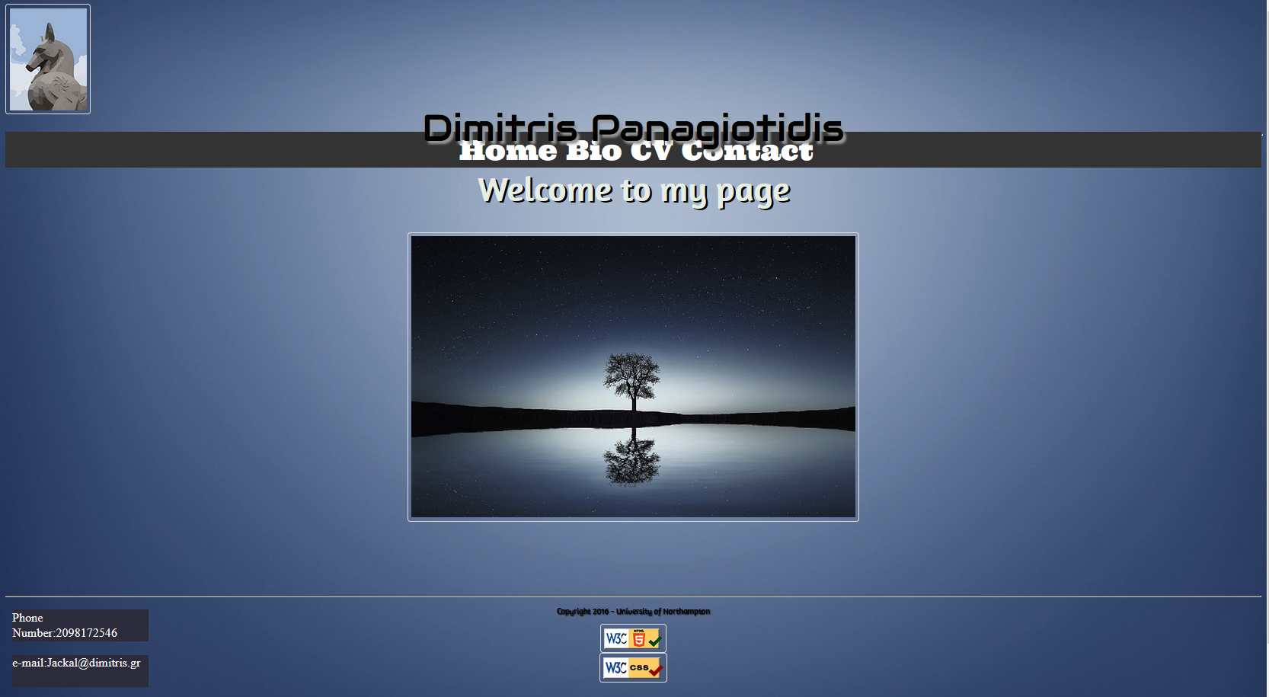

Logo up left, a navigation bar with all the links to explore the site on its full potential on the header. On the main body we see a welcome text and an image. On the footer I put the validators for HTML 5 and CSS, the copyrights and last but not least a flex box bottom left with some of my contact details.

Bio.html

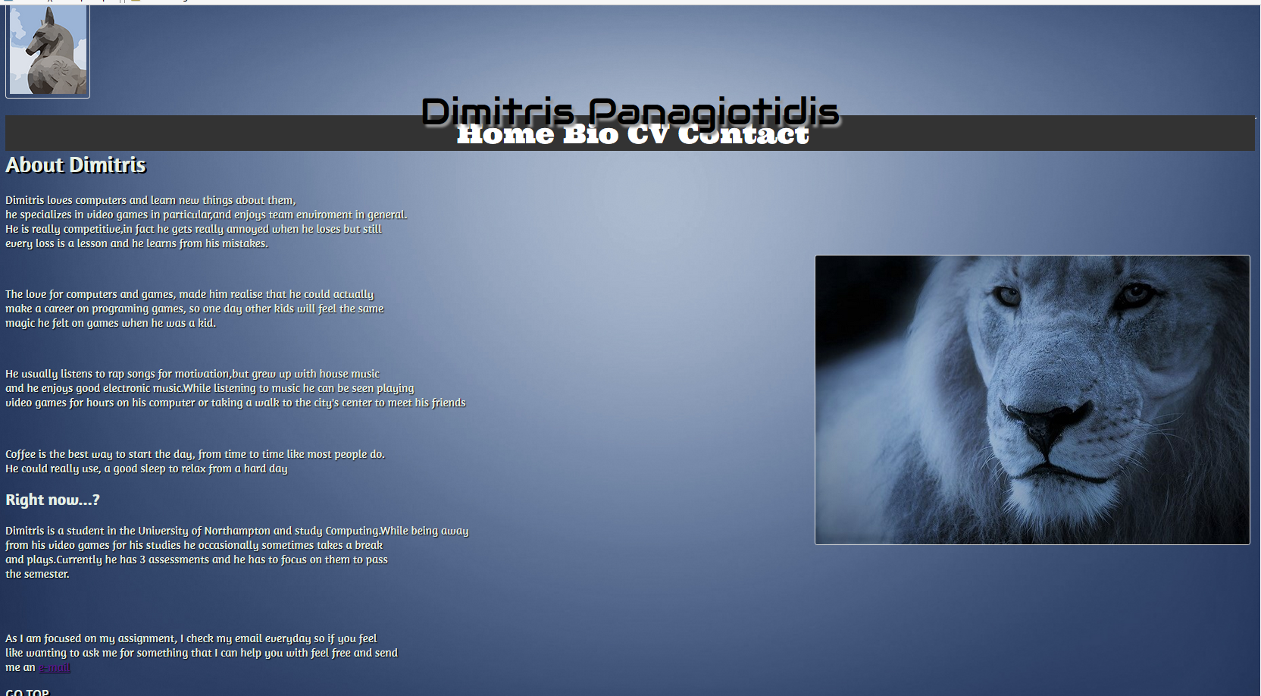

This is the bio.html that is linked to index page has most of the index page as for the header and footer but the main body has a bio story about me and a link to the contact page as a text at the end of bio.

cv.html

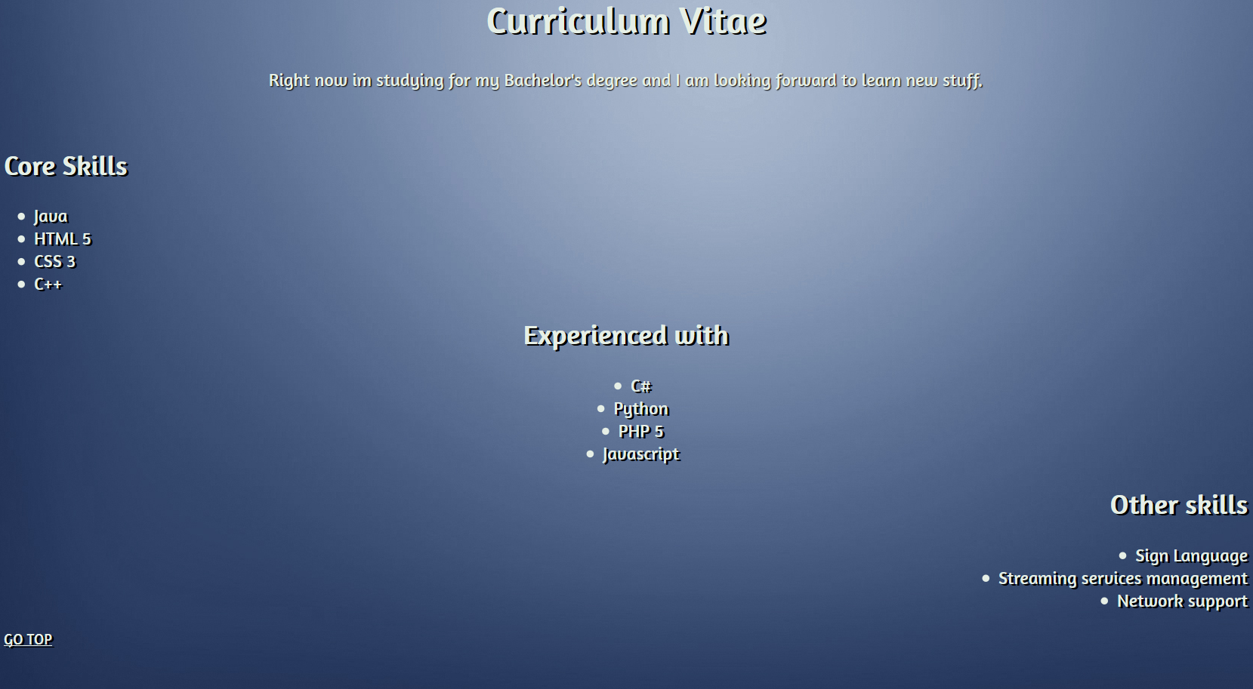

On the Curriculum vitae page I put my skills on unordered list, with what I am experienced with and my other skills such as Sign Language. Because this page is big I could not show it all in this report, but still the rest of the page looks like index.html as well.

Contact.html

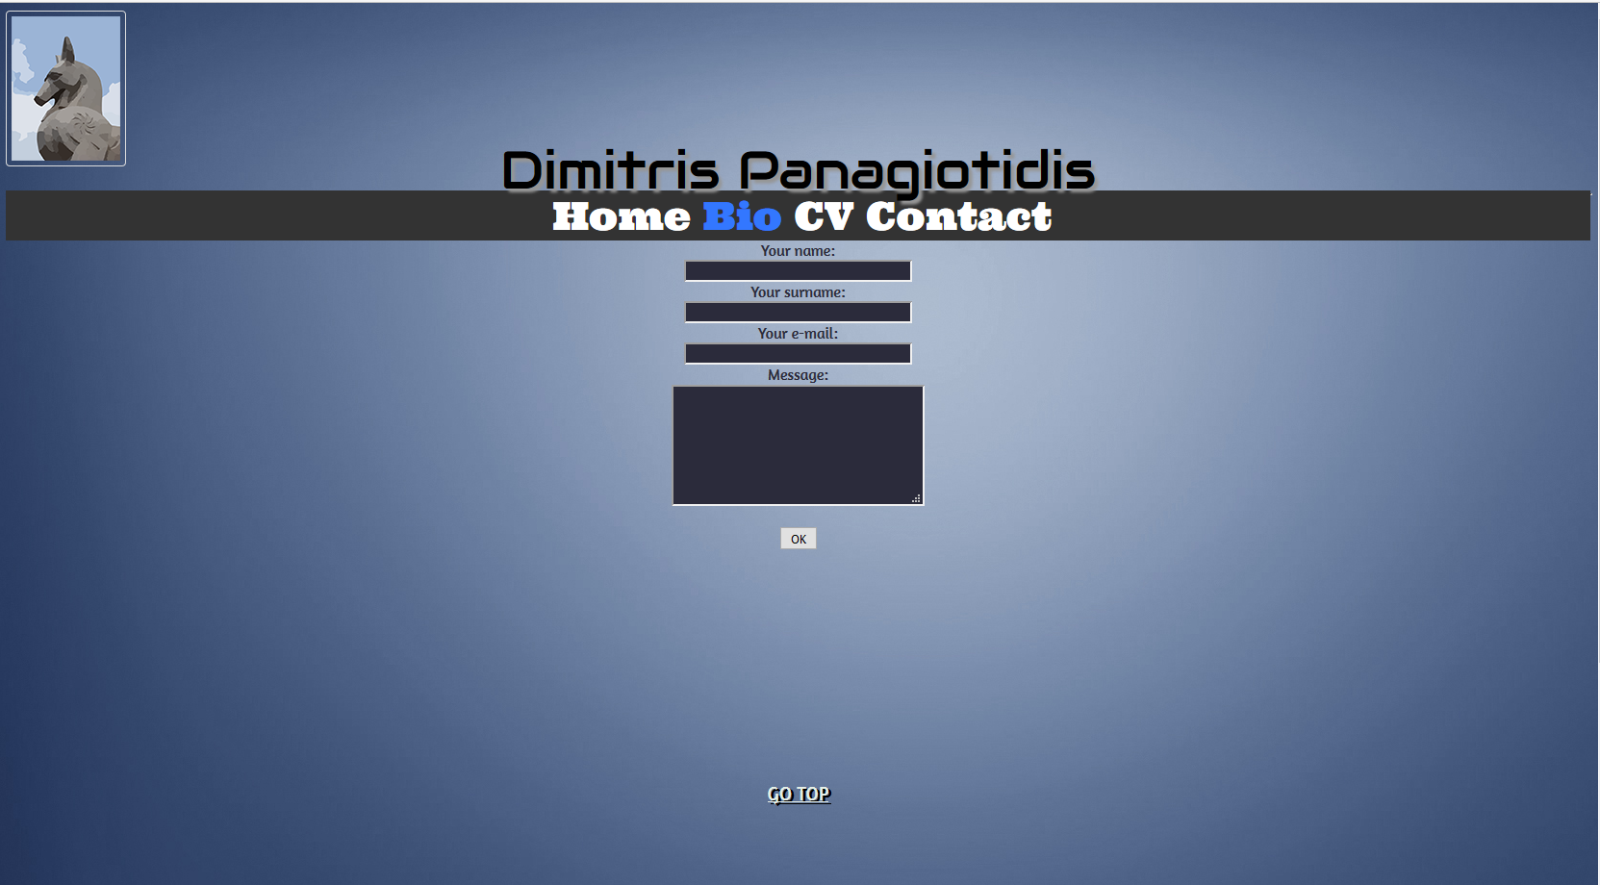

The contact page contains a contact form which can be used by the user to send me an email, after they fill the blank spaces and press ok the page will return to its normal form as it was in the beginning with empty boxes ready to be filled again for a message.

Footer & Flexbox

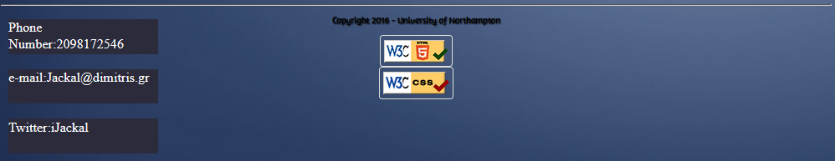

The footer includes the 2 validators and a flex box It is used on all the pages.

**References**

W3schools.com. (2017). *W3Schools Online Web Tutorials*. [online] Available at: http://www.w3schools.com/ [Accessed 5 Jan. 2017].

Google Fonts. (2017). *Google Fonts*. [online] Available at: https://fonts.google.com/ [Accessed 5 Jan. 2017].

Stanford, J. (2017). [online] Available at: https://joel.sh/ [Accessed 5 Jan. 2017].

Stackoverflow.com. (2017). *Stack Overflow*. [online] Available at: http://stackoverflow.com/ [Accessed 5 Jan. 2017].